**SOLREI: The Universe and the Solar System, a Virtual E-Learning Mobile Application**

Justine Joy D. Viernes, Cristopher E. Leal, Ferr Ian Arabos,

Harold Clarence Balayanto, Jovan Rey B. Javier

**I - INTRODUCTION**

Today’s era is known as the modern technology [1]. Modern technology plays a very important role in the lives of people simply because technology made a great contribution in giving the people convenience in whatever possible way. The influence of technology to different fields can be easily perceived, especially in the field of education. The impact of technology in the field of education is undeniably important and cannot be ignored. It is generally known that over the last few years, the rise to the increased development of information and communication technologies have abundantly influenced the field of education, due to the successful and advanced environment which have emerged from the influential impacts of globalization [2]. There are many circumstances that can prove that the use of modern technology caters a significant influence in the learning and interactivity of students. With the use of modern tools and equipment, students tend to become more attentive and participative in class discussions making the teaching and learning process entertaining and more compelling.

As a result of the rapid growth of technology and advancements in the teaching and learning process, e-learning also referred to as the online learning or electronic learning made its way to be acknowledged and acclaimed in the field of education. This is mainly because of its numerous advantages over the traditional learning methods [3]. E-Learning can be defined in different ways. It can be defined as the acquisition of knowledge which occurs through electronic technologies and media or as [4]an organized course or learning experience delivered electronically that can also include performance support content. Students nowadays have experienced an immeasurable impact of e-learning. One of the impacts of e-learning is it has brought among the students the sense of self-responsibility [5]. It also allows the students to practice their critical thinking skills and broaden their knowledge by researching using the internet. E-learnings can benefit the students in different ways and there are a lot of occurrences that can prove that. Aside from promoting active and independent learning, it is also convenient and flexible that students do not need to depend on anyone for anything.

One of the most significant topics in the IT industry nowadays is virtual reality and its application in different domains. The field of education is not an exemption. Virtual reality (VR) refers to a computer-generated simulation in which a person can interact within an artificial three-dimensional environment using electronic devices, such as VR box and virtual reality glasses [6]. This simulated artificial environment can make the users experience an immersive artificial world that can seem quite real. Virtual reality in the field of education is continuously generating its track to new resources to improve the teaching and learning experience [7]. Because of the digital technology era right now, knowledge became more accessible. Providing information and facts in a short period of time is the main focus of the current teaching methods that results in disengagement and boredom. Education must go along with the new ways of technology to sustain the engaging and effective learning experience. It will help students fully understand the lessons when they are involved in what they are learning.

That can be made possible by virtual reality. One of the top benefits of virtual reality in education is that it improves understanding. Virtual reality contributes in making the class exciting and helps the students to understand and easily comprehend difficult concepts by visualizing. Another benefit of virtual reality to education is that it enables students to learn through experience. Through virtual reality, the information is a lot more relevant and students will have an opportunity to learn by doing than simply reading. It can also help in minimizing the gap between teachers and students in distance education.

This study is focused in developing a virtual reality e-learning mobile application which can be used as an additional learning material for the Grade-6 students of Panpacific University North Philippines, Tayug Campus. The proposed mobile application is designed with user-friendly graphical user interface (GUI) which is pleasing to the eyes of the students.

**Objectives of the Study**

The main objective of this study is to design and develop the SOLREI: The Universe and the Solar System, a Virtual e - Learning Mobile Application for Grade-6 students of Panpacific University North Philippines Tayug Campus.

The following are the specific objectives of this study:

1. to determine the problems encountered and the current procedures in teaching the Solar System and the Universe,
2. to design the modules and features of the proposed application, and
3. to identify the user and system acceptability.

**Significance of the Study**

The SOLREI: The Universe and the Solar System, a Virtual E-Learning Mobile Application will give significance to the following:

The PUNP Tayug Campus. This study will further improve the university in the development of every student’s education. This study will promote new ways of enriching skills and knowledge hence, preparing globally-competent graduates in the future.

The Grade 6 students. This study will help the students enhance their knowledge. It shall serve as an additional learning material for them to learn and understand better the topic the universe and the solar system.

The Parents and Teachers. This study will help the parents and teachers in monitoring the progress of the children about the topic. It will also help the teachers in making every student participate during the discussions.

The Future Proponents. This study will benefit the future proponents as it would give them ideas about their future research. The ideas presented in this study can also be used as a reference data in conducting new research.

**Scope and Limitations**

This study is focused in developing a virtual reality mobile application for the Grade-6 students of Panpacific University North Philippines Tayug, Campus. The system will serve as an additional learning material to the students about the topic The Universe and the Solar System. It is also an effective tool to enhance student engagement during discussions. The system has an e-lesson feature that contains the lesson about each planet and any other members of the solar system. The mobile application also supports a virtual reality viewing of the solar system and has audio stating short information about each planet. It also has a virtual reality quiz feature that allows the students to assess what they have learned in the topic from the lessons provided. The system runs only on Android operating systems version 7 and up. The developed mobile application is an automated rendition of the textbooks used by the teacher and the Grade-6 students of Panpacific University North Philippines Tayug, Campus.

**Conceptual Framework**

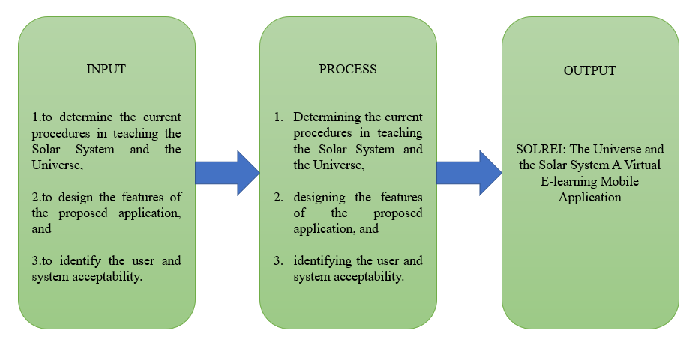 The proponents developed a mobile application that aims to help improve the teaching and learning process of the Grade-6 students of Panpacific University North Philippines Tayug Campus about the topic, The Universe and the Solar System.

Figure 1. Paradigm of the Study

INPUT. Identifying the problems encountered and the current procedures in teaching the topic the universe and the solar system to the Grade-6 students of PUNP Tayug Campus is essential as it will be the input of the proposed mobile application. It will also include the features of the system as well as the user and system acceptability

PROCESS. The process is to identify the current procedures in the teaching and learning process of the Grade-6 students of PUNP Tayug Campus about the topic The Universe and the Solar System; design the features of the proposed mobile application; and determine the user and system acceptability. In developing the mobile application, the proponents used, Unity 3D, C# for the scripts and Adobe Photoshop for the design.

OUTPUT. As the result of this process, the proposed system, SOLREI: The Universe and the Solar System, a Virtual E-Learning Mobile Application was developed.